Step 1: Create a file using text editor using the command gedit class.sh
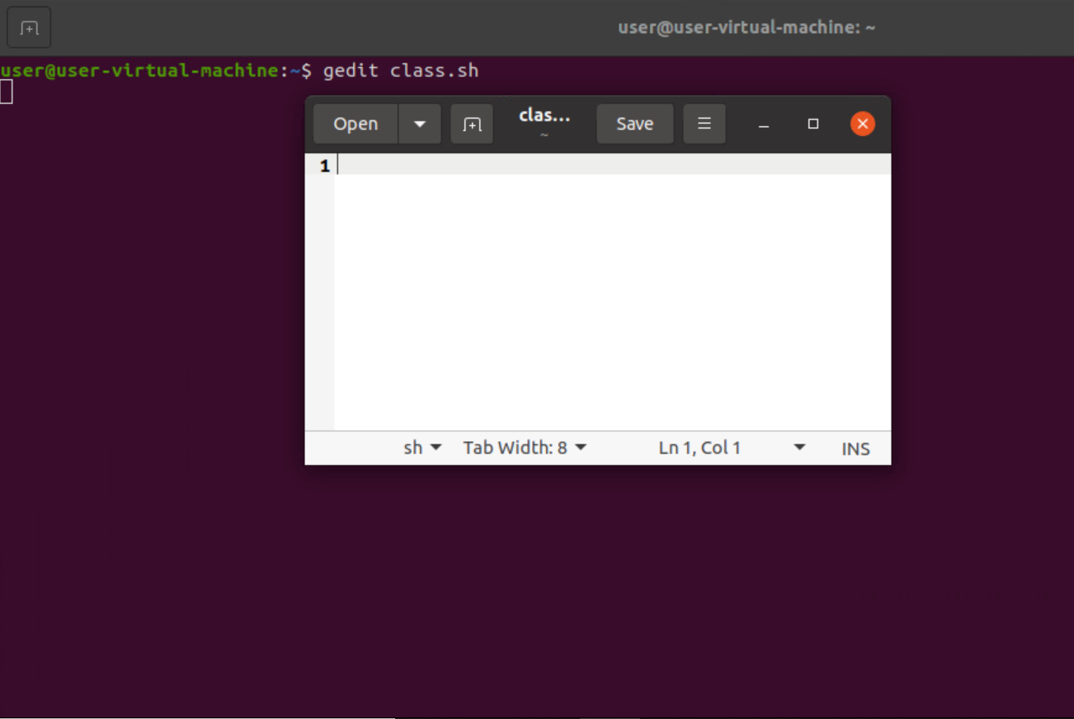
Step 2 : Here in the editor type the code
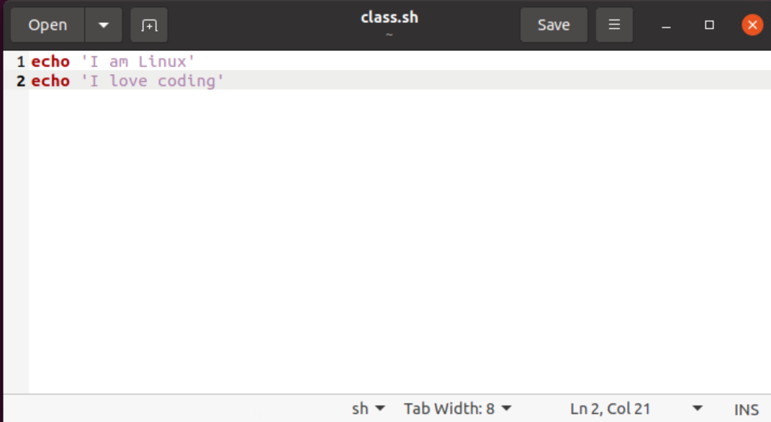

Step 3: Set the script executable permission by running chmod command in linux using chmod +x class.sh coomand

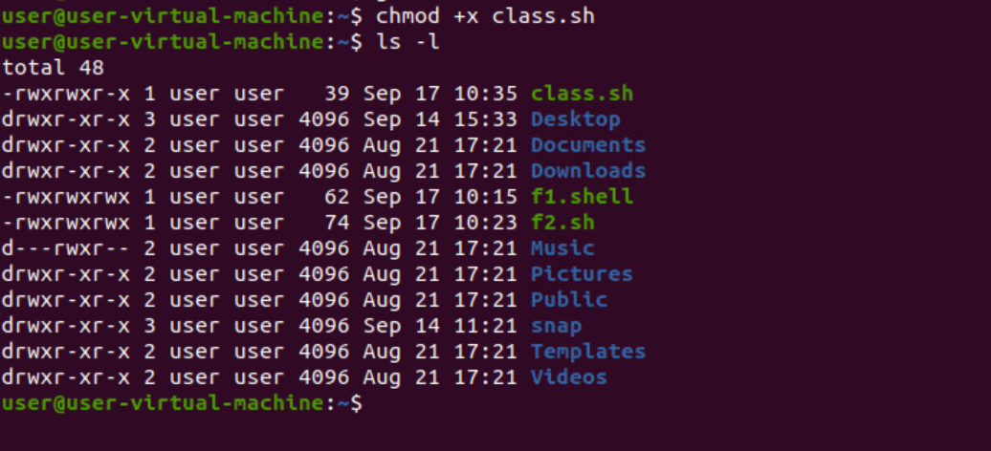

WAP to calculate Simple Interest.
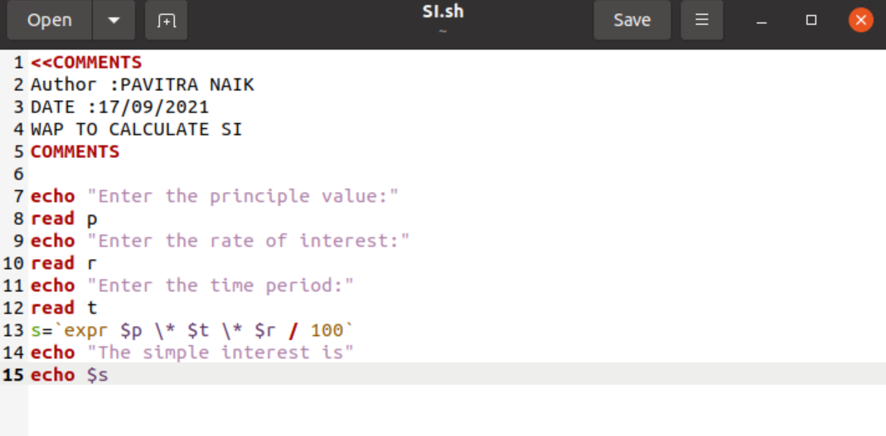

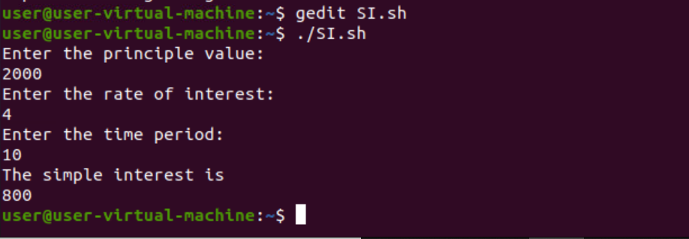

WAP to calculate circumference of circle.

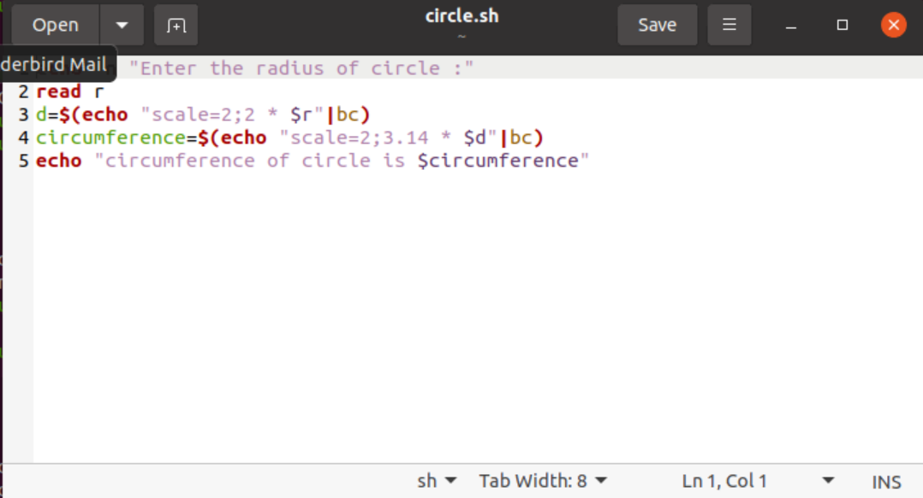

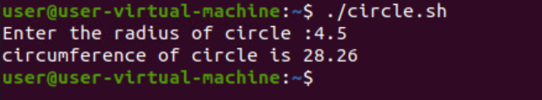

WAP to diognol og rectangle.
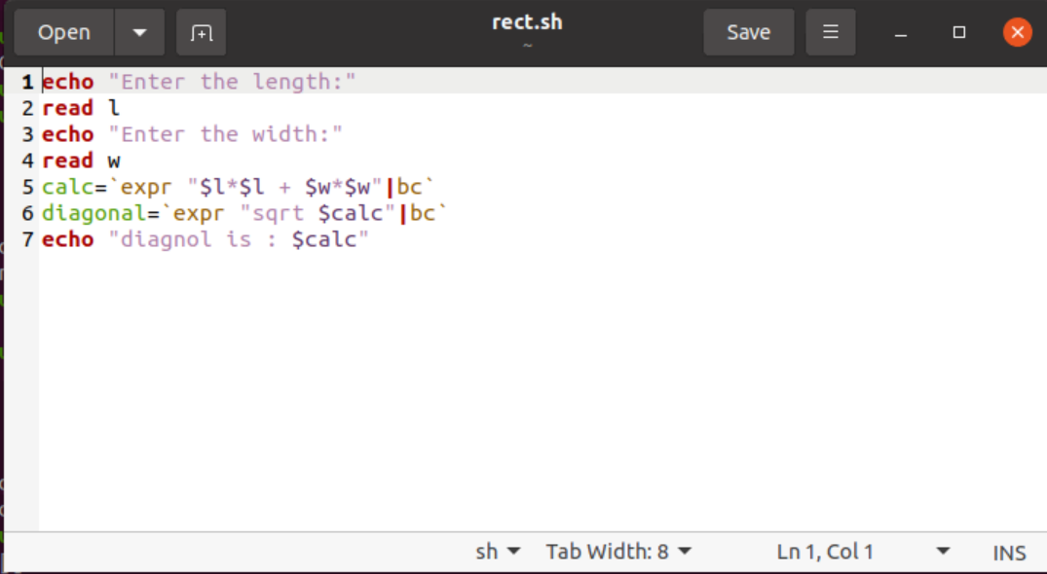

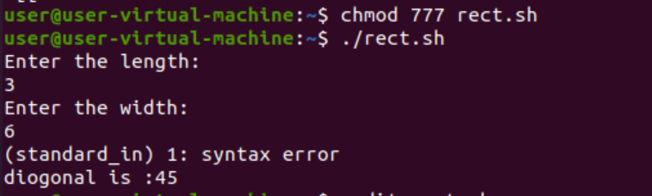

1. WAP to print table of numbers.
echo "Enter a Number"
read n
i=0
while [ $i -le 10 ]
do
echo " $n x $i = `expr $n \* $i`"
i=`expr $i + 1`
done

2. WAP to print a pattern like *
* *
* * *
* * * *
* * * * *
echo “Enter a Number”
read rows
for((i=1; i<=rows; i++))
do
for((j=1; j<=i; j++))
do
echo -n “*”
done
echo
done

3. WAP to print numbers in pattern 1 2 3 4
5 6 7
8 9
10
start=1
echo ”number of lines”
read n
for((i=n; i>=1; i—))
do
for((j=1; j<=i; j++))
do
echo -n “$start+1))
done
echo
done

